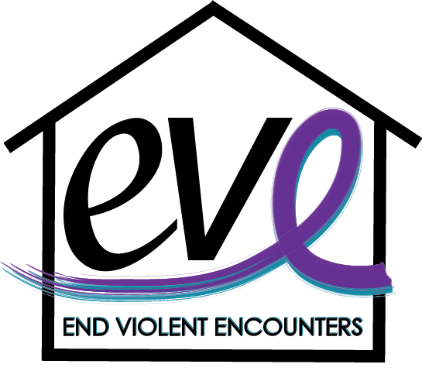
Domestic Violence Awareness Program

Did you know? On average, nearly 20 people per minute are physically abused by an intimate partner in the United States.

What is Domestic Violence?
A pattern of abusive behavior in any relationship that is used by one partner to gain or maintain power and control over another intimate partner.” (United States Department of Justice Definition)

Target Audience: Any

Program Description
This training program is geared toward raising awareness around the topic of domestic violence, the services EVE offers to survivors, how to connect someone to those services and other ways you can assist them on their journey of healing. Through this program, you will develop competencies in recognizing the warning signs of domestic violence, understanding the dynamics of power and control in unhealthy relationships, cyber abuse and common myths associated with domestic violence. This program will also help expand your knowledge of local services and resources to help empower survivors.

Program Objectives
- Define what domestic violence is and who it affects.
- Recognize warning signs of domestic violence and become familiar with the power & control wheel.
- Learn how technology is contributing to domestic violence, what it look like and how it can be navigated with teens.
- Learn to debunk the myths of domestic violence and tackle one of the most commonly asked questions. “Why don’t they just leave?”
- Become aware of local resources available to assist survivors who are experiencing domestic violence and how you can help them if you suspect they are in an unhealthy relationship.

*Additional learning objectives can be added to tailor this training

Contact Information
EVE (End Violent Encounters), Inc.
Leah Dryer  Director of Community Outreach  ldryer@eveinc.org  (517) 372-5976 Ext. 111 | Sam Stiles  Community Outreach Coordinator  sstiles@eveinc.org

