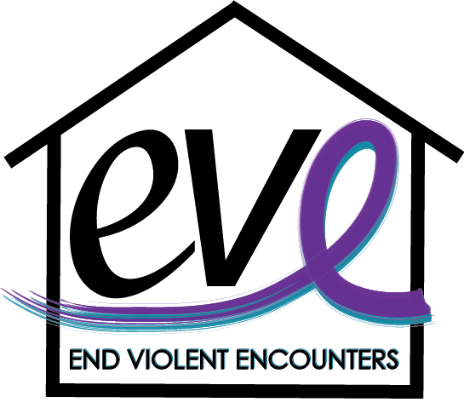
Teen Dating Violence Awareness Program

Did you know? Nearly 1.5 million high school students nationwide experience physical abuse from a dating partner in a single year and only 1 in 3 teens will disclose their abuse.

What is Teen Dating Violence?
Dating violence is a pattern of behavior that includes physical, emotional, verbal or sexual abuse used by one person in a relationship to exert power and control over another.

Target Audience: High Schoolers 9th grade and up

Program Description
This training program is geared toward teaching students and staff the importance of being able to recognize dating violence and how to help someone who may be experiencing it. Through this program, you will develop competencies in recognizing the warning signs of dating violence, understanding the dynamics of power and control in unhealthy relationships, cyber abuse and bullying, and learn what healthy boundaries are and how to establish them with others. This program will also help expand your knowledge of local services and resources to help empower survivors.

Program Objectives
- Define what dating violence is and who it affects.
- Recognize warning signs of a potential dating violence and/or sexual assault situations and become familiar with the teen power & control wheel.
- Learn how technology is contributing to dating violence, what it look like and how it can be navigated with teens.
- Learn what it means to practice and use everyday consent to help establish and maintain healthy boundaries with those around you.
- Become aware of local resources available to assist teens who are experiencing dating violence and how you can help them if you suspect they are in an unhealthy relationship.

*Additional learning objectives can be added to tailor this training to your own school’s experiences and needs.

Contact Information
EVE (End Violent Encounters), Inc.
Leah Dryer  Director of Community Outreach  ldryer@eveinc.org  (517) 372-5976 Ext. 111 | Sam Stiles  Community Outreach Coordinator  sstiles@eveinc.org

